EDA Task Report

TASK 1: Data Familiarization
First, I did basic non-visual EDA to understand the dataset: Size, shape, column names, data types, missing values, basic statistics and a preview of the first 5 rows.
The insights I got from this:
- Zero Missing values!!
- Extreme right skew
- Spatial Locations play an important role
- MedInc, AveRooms, and AveBedrms are directly proportional to the target (HouseValue)
- House Age, Population, and AveOccup are inversely proportional
- Due to highly different values used in features (in tens for some, thousands in others), we may need to standardize them in the future.
Based on these, I decided to plot these graphs:
- MedInc vs HouseValue => scatter plot
- Latitude vs Longitude => spatial scatter
- AveRooms vs HouseValue => scatter plot
- Distribution of each feature => histograms
Conclusion of Task 1:
- Target Cap: HouseValue is capped at 5.0, as seen by the sudden spike on the far-right side of its histogram
- There is a strong, positive, and linear correlation between MedInc and HouseValue
- Coastal Areas have higher house values than inland ones
- Most typical households have 4-6 rooms, and once rooms >7, variance is high, and the correlation to the target weakens.
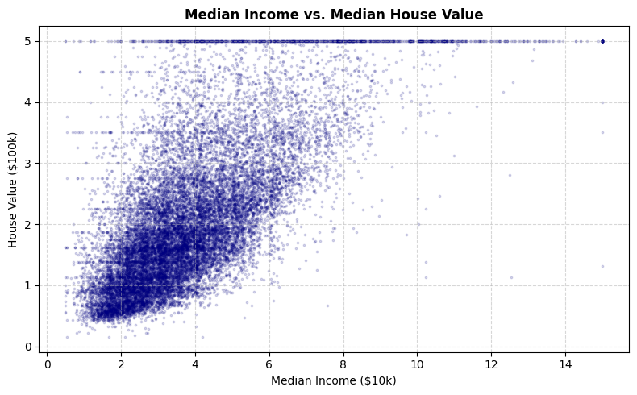

TASK 2: OLS vs kNN
Here is the comparison between the global model (OLS) and local model (k-Nearest Neighbours), especially to see how they respond to extreme data points.
I chose a single key feature – MedInc, due to its overwhelming correlation with HouseValue against others.
Conclusion of Task 2:
- OLS (global line): fits a smooth, rigid, linear (straight) line; completely misses out on the cap at 5.0; high bias and inability to bend to fit real data/price ceilings
- kNN (local average): looks at the 20 closest data points; caps out at 5.0 since most of the neighbours have that value; fits the local trends well, but in places of sparse data due to distant points have jagged bumps

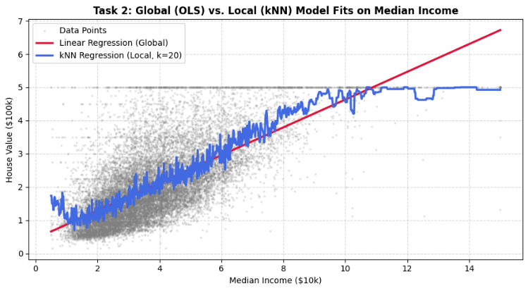

TASK 3: Loss Functions
The aim here is to see how heavily the loss functions penalize outliers, leading to misinterpretation of the data. For this purpose, I took a subset of MedInc< 3.0 due to a heavy presence of right-skewed data points.
Conclusion of Task 3:
- L2 (the mean): global min. at 1.34 = dataset mean. Since it ‘squares’ the residuals => heavy penalty on large outliers, deviating data towards the right
- L1 (the median): global min. at 1.15 = dataset median. Since it errors ‘linearly’, there is relatively less penalty on outliers, giving a more grounded estimator.

TASK 4: Distance Growth and Curse of Dimensionality
This task is to understand how increasing the distance between data points and the expansion of the space by addition of features affects the generalization of OLS and kNN.
Conclusion of Task 4:
- As dimensions expand from $1$ to $8$, the average distance to a point's nearest neighbor climbs steadily from $0.00$ to over $0.34$
- Except for the first dimension, kNN outperforms OLS due to its comparatively steeper drop, implying it is more dimensionally impacted than OLS
- 8 dimensions is still low enough not to negatively impact kNN
- The sharpest fall in both is after the addition of spatial information, indicating its high weightage

OPTIONAL TASK:
I am using Ridge and Lasso in this case.
Conclusion of Optional Task:
- The Lasso produces a diamond hyperplane restriction and the sharp edges forces weaker features to drop to zero
- The ridge produces a circular constraint with smooth edges, so even if some features with weak correlation have a coefficient value approaching zero, it never become zero
- Both of these have some added bias, mainly to massively reduce the variance in OLS
- The reason of high variance is OLS is since there are features that correlate each other, the unconstrained model tends to overfit and consider noise
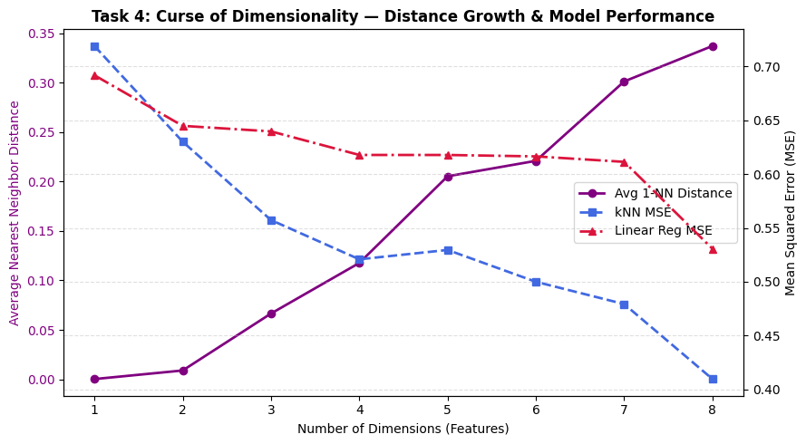

Based on performance metrics: kNN is the better model
